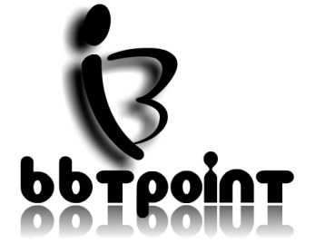

**Contact Us:**

[**info@bbtpoint.com**](mailto:info@bbtpoint.com)

**9650307449**

**Terms & Conditions:**

1. We take 75% as initial payable which is refundable as we receive the book and charge 25% for first 15 days for rental and if you want book for more time period charges will applied as follows:
   1. First 15 days – 25%
   2. Next 15 days – 10% (25%+10%)
   3. Next 15 days – 10% (25%+10%+10%)
2. You cannot rent book for more than 45 days. If you do so, then the initial payable will not be refunded.
3. To receive a refund, you must return your item and in the same condition you received it in.